**BWT Task-06 Exercise**

**Submitted By: Abduhu Khan**

**Q1**

**Write a query to retrieve all orders placed by customers, including customer details (name, phone), order details (order ID, timestamp), and item details (product, amount).**

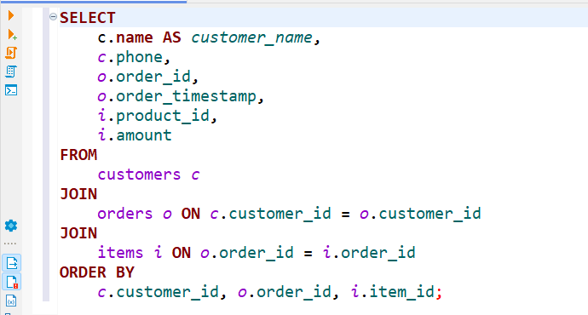

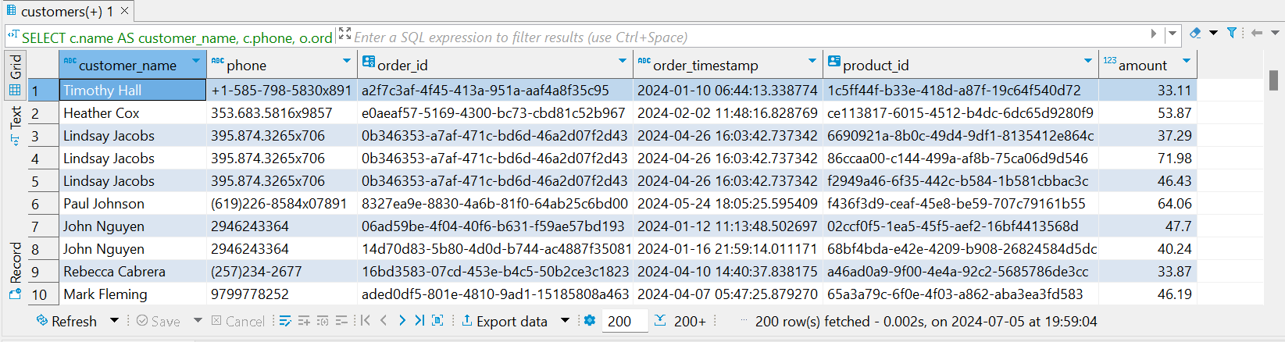

**SELECT**

c.**name** **AS** *customer_name*,

*c*.phone,

*o*.order_id,

*o*.order_timestamp,

*i*.product_id,

*i*.amount

**FROM**

customers *c*

**JOIN**

orders *o* **ON** *c*.customer_id = *o*.customer_id

**JOIN**

items *i* **ON** *o*.order_id = *i*.order_id

**ORDER** **BY**

*c*.customer_id, *o*.order_id, *i*.item_id;

**Q2**

**Write a query to fetch all products along with their suppliers' details (name, phone) and the corresponding category name.**

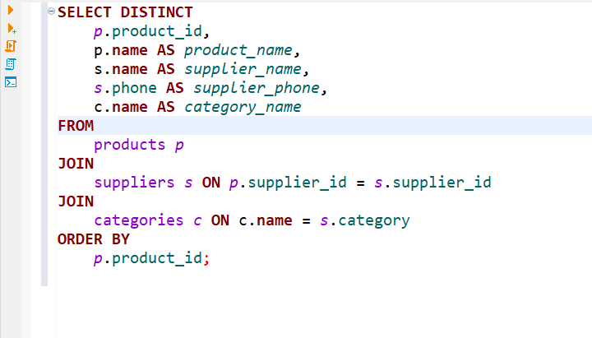

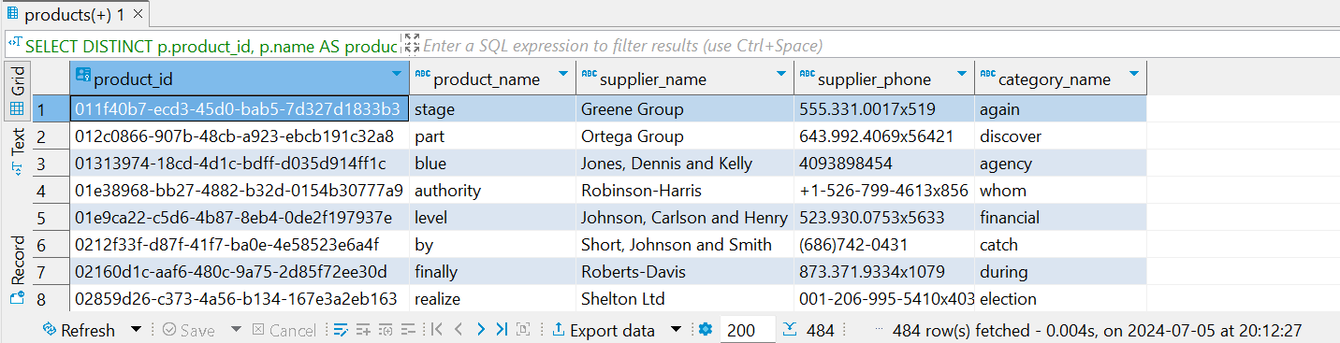

**SELECT** **DISTINCT**

*p*.product_id,

p.**name** **AS** *product_name*,

s.**name** **AS** *supplier_name*,

*s*.phone **AS** *supplier_phone*,

c.**name** **AS** *category_name*

**FROM**

products *p*

**JOIN**

suppliers *s* **ON** *p*.supplier_id = *s*.supplier_id

**JOIN**

categories *c* **ON** c.**name** = *s*.category

**ORDER** **BY**

*p*.product_id;

**Q3**

**Write a query to retrieve details of all orders including the product name and amount ordered for each item.**

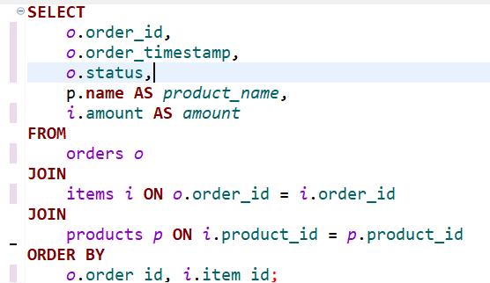

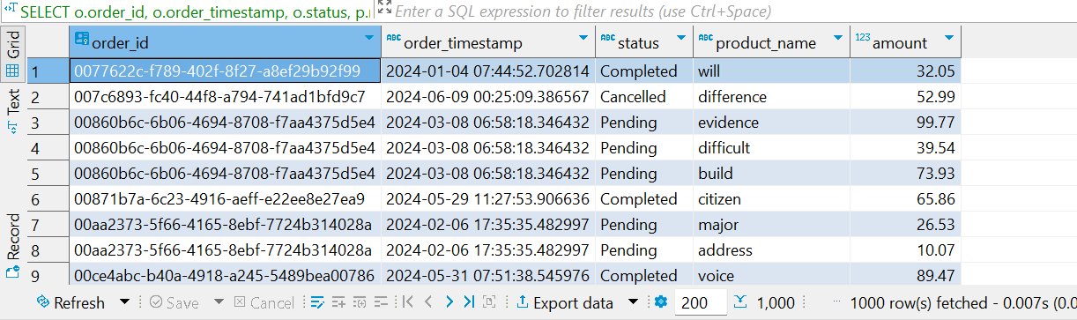

**SELECT**

*o*.order_id,

*o*.order_timestamp,

*o*.status,

p.**name** **AS** *product_name*,

*i*.amount **AS** *amount*

**FROM**

orders *o*

**JOIN**

items *i* **ON** *o*.order_id = *i*.order_id

**JOIN**

products *p* **ON** *i*.product_id = *p*.product_id

**ORDER** **BY**

*o*.order_id, *i*.item_id;

**Q4**

**Write a query to retrieve all suppliers along with the city and country where they are located, and the products they supply.**

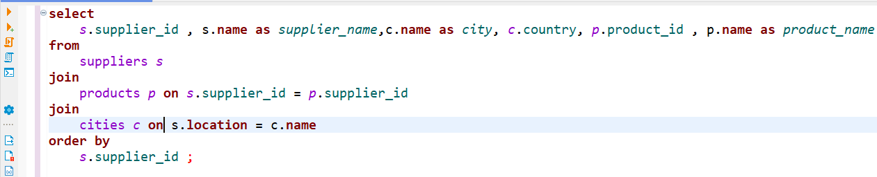

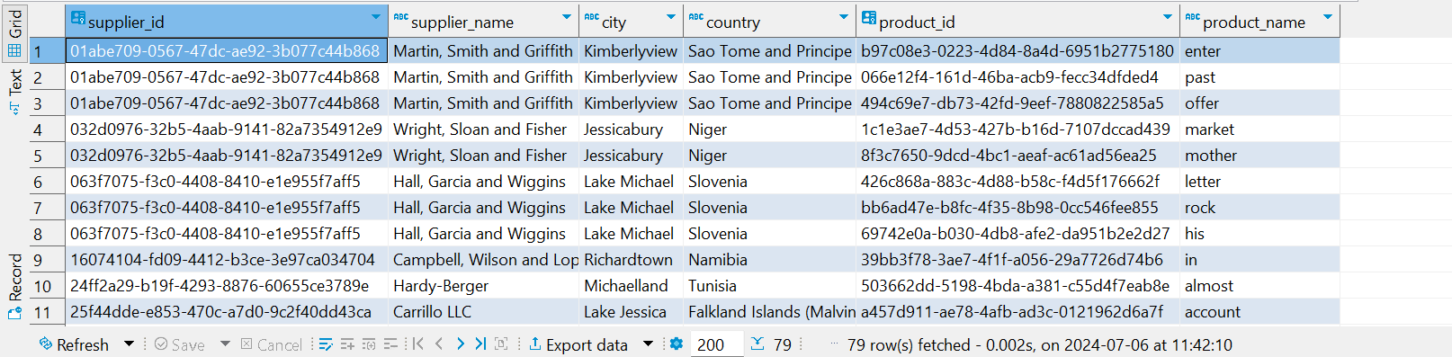

**select**

*s*.supplier_id , s.**name** **as** *supplier_name*,c.**name** **as** *city*, *c*.country, *p*.product_id , p.**name** **as** *product_name*

**from**

suppliers *s*

**join**

products *p* **on** *s*.supplier_id = *p*.supplier_id

**join**

cities *c* **on** s.**location** = c.**name**

**order** **by**

*s*.supplier_id ;

**Q5**

**Write a query to fetch details of the most recent order (by timestamp) placed by each customer, including the product details for each item in the order. [This question will use a Window Function alongside Joins]**

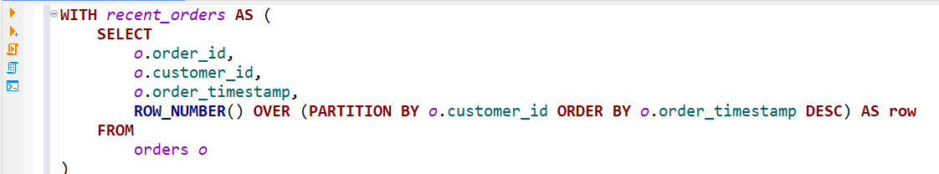

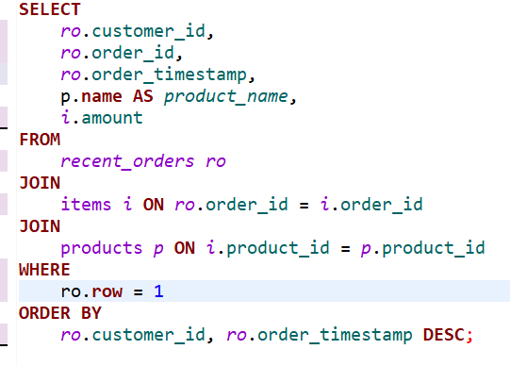

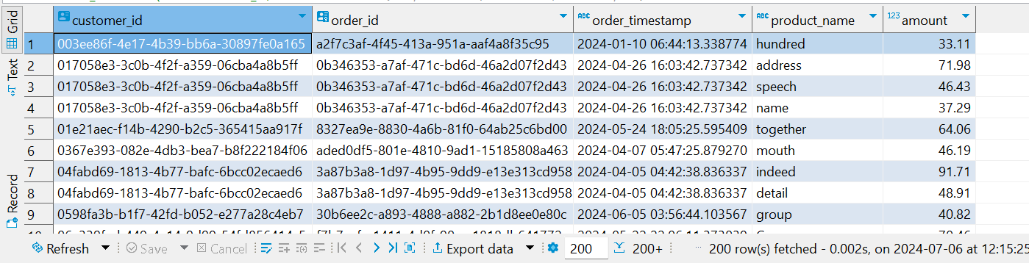

**WITH** *recent_orders* **AS** (

**SELECT**

*o*.order_id,

*o*.customer_id,

*o*.order_timestamp,

**ROW_NUMBER**() **OVER** (**PARTITION** **BY** *o*.customer_id **ORDER** **BY** *o*.order_timestamp **DESC**) **AS** **row**

**FROM**

orders *o*

)

**SELECT**

*ro*.customer_id,

*ro*.order_id,

*ro*.order_timestamp,

p.**name** **AS** *product_name*,

*i*.amount

**FROM**

*recent_orders* *ro*

**JOIN**

items *i* **ON** *ro*.order_id = *i*.order_id

**JOIN**

products *p* **ON** *i*.product_id = *p*.product_id

**WHERE**

ro.**row** = 1

**ORDER** **BY**

*ro*.customer_id, *ro*.order_timestamp **DESC**;